# Blockchain

# Chain Core

“Chain Core is infrastructure software that enables institutions to issue and transfer financial assets on permissioned blockchain networks”

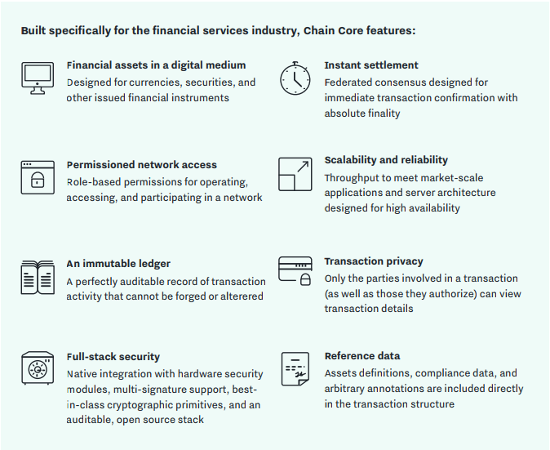

# Parking solution

contract TradeOffer(assetRequested: Asset,

amountRequested: Amount,

seller: Program,

cancelKey: PublicKey) locks offered {

clause trade() requires payment: amountRequested of assetRequested {

lock payment with seller

unlock offered

}

clause cancel(sellerSig: Signature) {

verify checkTxSig(cancelKey, sellerSig)

unlock offered

}

}

﻿

take a look at the TradeOffer contract (using the Load Template button). This contract locks up a piece of value called offered and there are two ways to unlock it:

* in trade, anyone who supplies the correct payment to the seller unlocks the value in offered
* in cancel, the seller supplies his or her signature to reclaim the value in offered

Let’s take a look at the steps involved in using something like the TradeOffer contract. One transaction uses it to lock up some value:

* Alice has 100 euros and wants 110 US dollars
* She creates a program by setting the parameters of TradeOffer as follows:
  + requestedAsset is USD (US dollars)
  + requestedAmount is 110
  + sellerProgram is the program where Alice can receive payment (payments and other transfers of value are always made “to” programs; see [the Appendix](https://chain.com/docs/1.2/ivy-playground/tutorial#appendix-contracts-programs-accounts-receivers-and-keys) for a discussion)
  + sellerKey is Alice’s public key
* Alice creates a transaction paying 100 euros from her account into the TradeOffer program she just created

A later transaction unlocks the value:

* Bob, who has dollars and wants euros, sees Alice’s transaction and creates a new one with two inputs and two outputs:
  + One input is Alice’s 100 euros, unlocked with the trade clause
  + One input is 110 dollars from Bob’s account
  + One output sends the 110 dollars to Alice’s sellerProgram
  + One output sends the 100 euros to Bob’s account

Or, alternatively, if Bob never comes along and Alice wants to withdraw her offer:

* Alice creates her own second transaction with:
  + One input that unlocks the 100 euros in the TradeOffer contract by supplying a signature matching the sellerKey specified earlier
  + One output paying those 100 euros back to Alice’s account

*Contract* parameters (including the locked value) are specified as part of the earlier transaction. *Clause* parameters (including any required payments) are specified as part of the later transaction.